Speech-to-Text Project

--User requirement document

Documented by NUS ISS Internship Team

6/30/2022

Table of Contents

1.Overview 3

1.1 User Requirements 3

1.2 Proposed Solution 3

1.3 Architecture 3

2. Technical Design 4

2.1 Analysis 4

2.1.1 Workflow 4

2.1.2 Data Acquisition 6

2.1.3 Speaker Diarization 6

2.1.4 Speech-to-Text 7

2.1.5 Speech-To-Text Model Fine-tuning 9

2.1.6 Extra Step - Word Replacement 12

2.1.7 Extra Step - Masking Profanity 14

2.1.8 Labeling 14

2.1.9 Use Case - Personally Identifiable Information (PII) Detection 16

2.2 Validation of Results 16

2.2.1 The Accuracy of STT Results 17

2.2.2 The Accuracy of Fine-tuned STT Results 19

2.2.3 The Accuracy of Word Replacement Function 21

2.2.4 The Accuracy of Labeling Model 22

3. Deliverables 22

3.1 Storage 22

3.2 Web Portal 24

3.3 Codes, Models & Configuration Files 31

3.4 Documentations 32

4. Recommendations for Further Work 32

4.1 For Finetune STT Model 32

4.2 For Web UI Design 34

4.3 For Text Analysis (Further Use Cases) 34

# 1.Overview

## 1.1 User Requirements

* Build a Speech-To-Text analysis in-house system.
  + - * Run all models offline. (Previous system was using Google Speech API.)
      * Distinguish different speakers and achieve speech-to-text at a relatively high accuracy for company’s audio.
      * Distinguish and label Agent and Customer.
      * Implement text analysis KYC, PII use case.
      * Audio data and analysis result can be saved and extracted successfully.
      * Build a user-friendly front-end UI with Python. (Previous system was using PHP.)

## 1.2 Proposed Solution

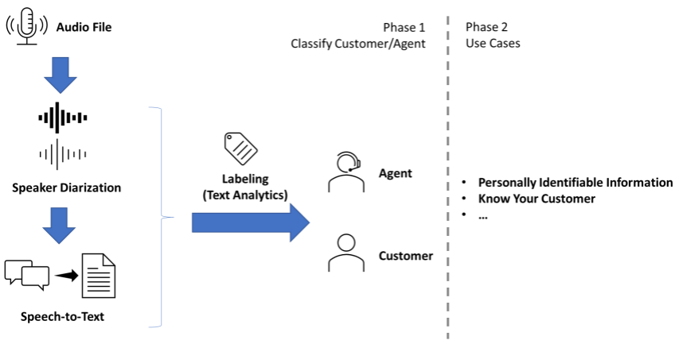

Figure 1.2(1) Proposed Solution

Figure 1.2(1) shows the proposed solution for this project. In phase 1, after getting the audio, we will first do the Speaker Diarization to separate speakers into speaker0 and speaker1, and then do the Speech-To-Text conversion. Based on the Speech-To-Text result, we will determine whether speaker0 or speaker1 is agent based on the conversation template provided by the bank. In phase 2, we will base on the text to perform analysis and review items for different uses cases, like identifying some customer personal information such as NRIC, passport number, email, credit card number and so on.

## 1.3 Architecture

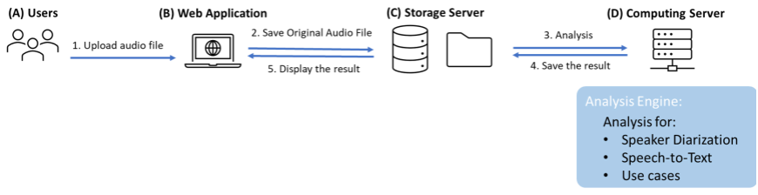

Figure 1.3(1) Architecture

Figure 1.3(1) shows the architecture of the project. Basically, this project is going to build an offline Voice-To-Text analysis system, which allows user to upload their audio to the system, and then the system will do the analysis in backend and abstract the information from the audio data, finally return the analysis result to the front-end and show on web pages.

The system requires a front-end framework, a storage server consisting of a MySQL database and a file system, as well as a backend engine in computing server to utilize the models.

# 2. Technical Design

## 2.1 Analysis

### 2.1.1 Workflow

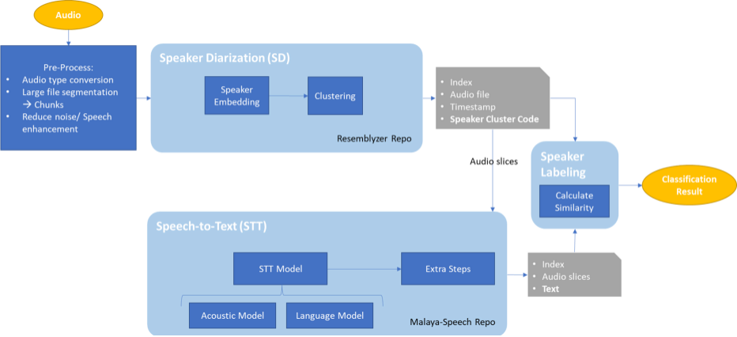

(a) Project Phase 1

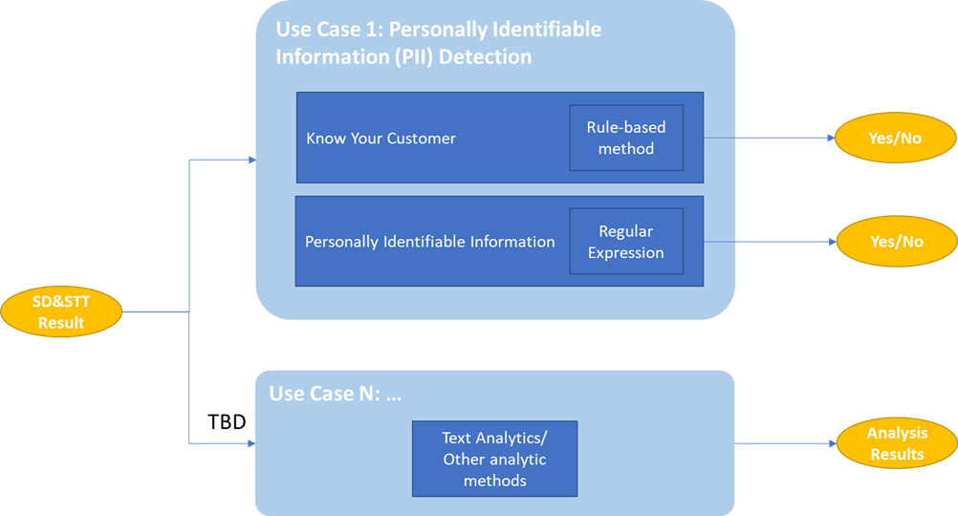

(b) Project Phase 2

Figure 2.1.1(1) Workflow (High Level)

Figure 2.1.1(1) shows the workflow of the entire project. The first phase consists of four parts: the audio pre-processing, the Speaker Diarization, Speech-To-Text, and Speaker Labeling; The second phase is about the analysis of the specific use cases. For the finalized use case 1, we analyze the results of phase 1 to detect whether the conversation contains personal information that can verify the identity of the customer. For the use cases to be determined, we provide the flexibility to add them to the system in future.

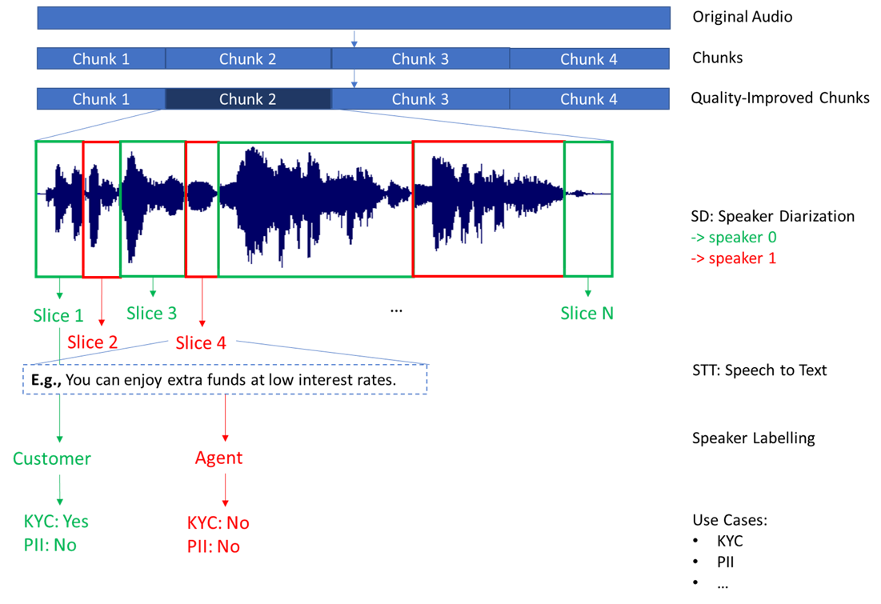

Figure 2.1.1(2) Workflow (Detailed Level)

The workflow can be shown more intuitively as above. When getting a long audio, we have to cut it in to chunks first to prevent overload and crash. And then for each chunk, we will apply quality improvement functions to improve the audio quality. After that, Speaker Diarization will distinguish the voices from different speakers and cluster wave frames into two clusters as two speakers. In each cluster, it contains one or more sentences but there will be only one speaker speaking. Later, the system will cut the audio into slices and Speech-To-Text conversion will be performed on each of them. Next, Speaker Labeling will determine which speaker is ‘agent’ or ‘customer’. Finally, from the text results of the STT, we will perform additional analysis for different uses cases on each audio slice.

### 2.1.2 Data Acquisition

- Data Source

* Source: Audio recordings from Call Center or Mystery Shopping Recording
* Data Type: Audio files (.wav, .mp3, ...)
* Acquisition Method: Extract from File System

- Data Acquisition Considerations

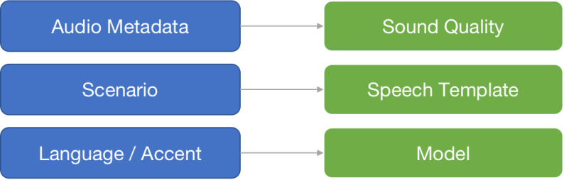

Figure 2.1.2(1) Data Acquisition Considerations

About data acquisition, we need to take these three components into consideration. The first one is audio metadata. Since different models we used have different requirements on the audios, we need to know the type of the audio file, the numbers of channels, the sample rate and so on. And also, audios in different scenarios have different conversation templates, which impacts the Speaker Labeling. At last, the language and accent have a big impact on the analysis results as well, so we also need to take this into consideration when preparing the STT model.

### 2.1.3 Speaker Diarization

After the audio file is ready for analysis, the first model is Speaker Diarization, which includes Speaker Embedding and Clustering. It will convert sound digital signals into feature vectors and cluster audio embeddings as different speakers. Most of the real situations will only have two speakers, so we set the model to diarize speech into two speakers. At last, we cut the audio file sentence by sentence following the SD results for further analysis.

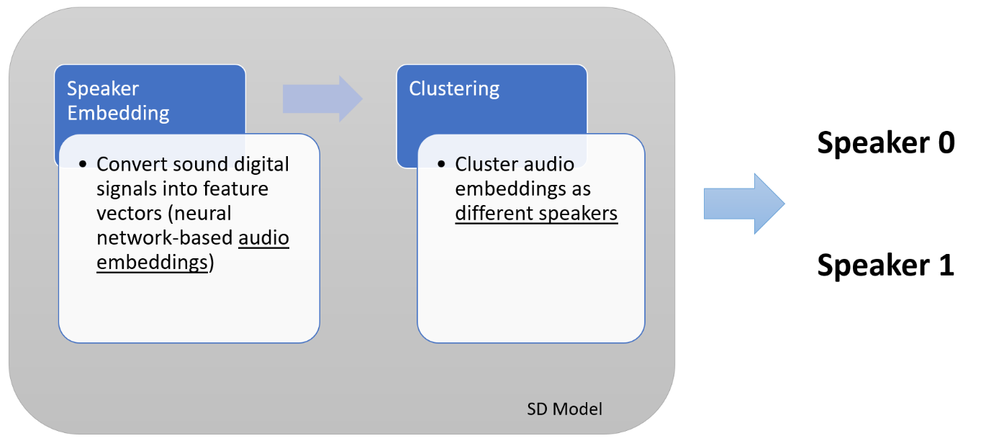

Figure 2.1.3(1) Speaker Diarization

In this step, we've tested three different models as shown below. Tested with the same samples, Malaya-Speech is fast enough, but its accuracy is moderate. pyannote.audio has higher accuracy, but its processing time is too long, and performance is not so good. However, Resemblyzer processing time is short enough, and it also can reach a very high accuracy, so it is our final choice. However, it also has some limitations, like its sound detection is sensitive, so the result contains many empty slices.

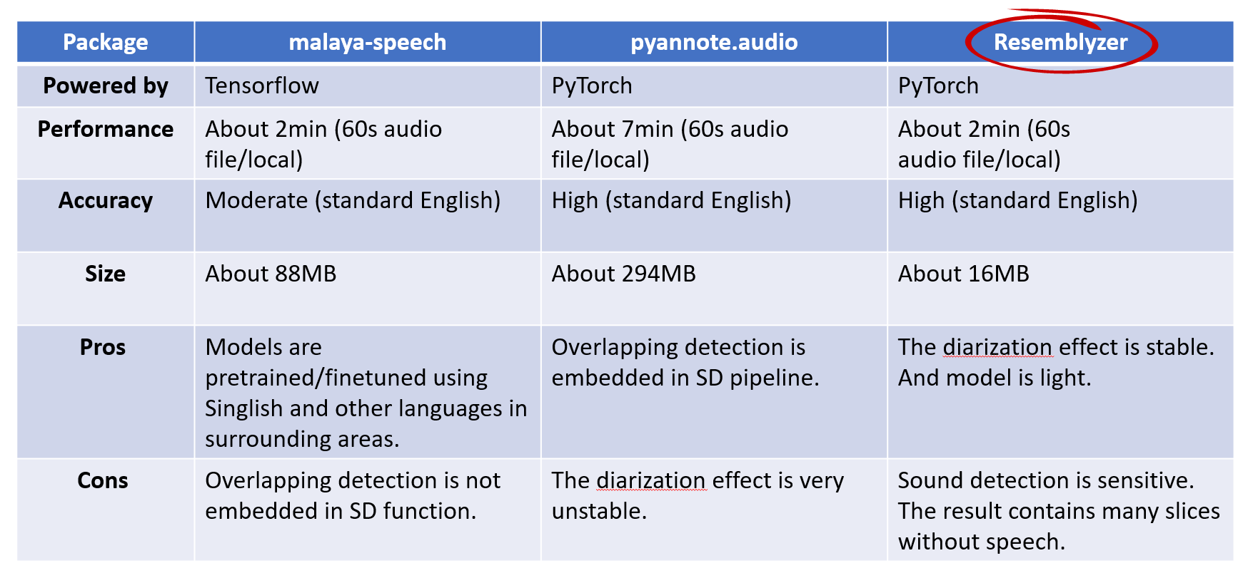

Figure 2.1.3(2) SD Models Comparison

### 2.1.4 Speech-to-Text

Next step is Speech-To-Text Conversion.

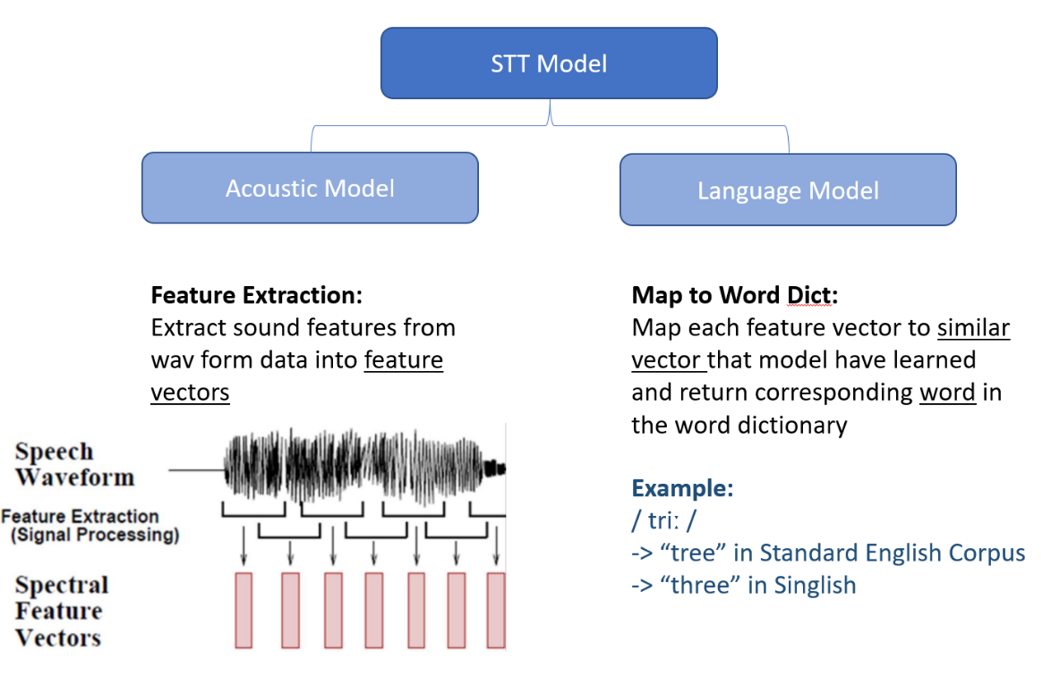

Figure 2.1.4(1) STT Model Structure

A STT model includes two parts, acoustic model and language model. For our situation, most audios are spoken in Singlish, but most pretrained models are trained on US or UK accent corpus. In this case, the most important task is to find a best match model or fine-tuning one to get the best performance.

In order to do so, we evaluated many in-house models and get the results as shown in Figure 2.1.4(2). With the speech recognition model as reference, we compared the accuracy and time-consumed between different models.

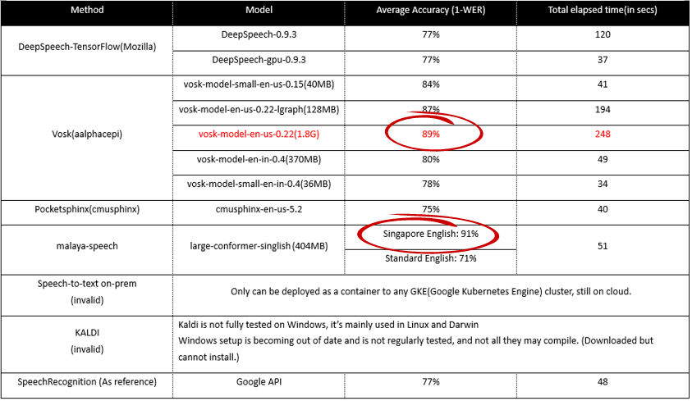

Figure 2.1.4(2) STT Models Comparison

Based on the evaluation result, although VOSK with its largest model took the longest processing time, it still has the highest accuracy. Meanwhile, Malaya-Speech has a very impressive accuracy when testing with Singlish corpus, so we kept these two models as final round candidates. We did all these first-round tests based on our own data, most are standard English corpus, and they are smooth and clear, but when we deployed both models to company environment and tested with real data, VOSK accuracy reduced a lot due to the audio quality and accent issue, so after we completed the comparison between these two models, we finally chose Malaya-Speech as our base pre-train model.

### 2.1.5 Speech-To-Text Model Fine-tuning

#### 2.1.5.1 The Reasons and Goals

Malaya-Speech STT model has been trained on a large corpus of Singlish and achieved a good recognition result on company’s audios. However, we still wanted to target the model more towards company’s audios and get more accurate recognition of some accents and terms in the context of UOB group and banking industry, so we decided to fine-tune Malaya-Speech STT model with company’s audios.

#### 2.1.5.2 Workflow

For an STT model with a base framework of wav2vec2, we can use the following fine-tuning process：

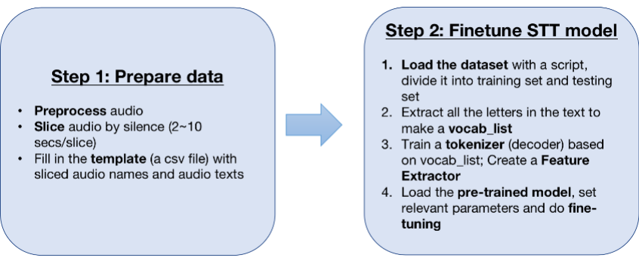

Figure 2.1.5.2(1) Workflow of Fine-tuning

#### 2.1.5.3 Fine-tune on Malaya-Speech

STT model in Malaya-Speech repository is an open-source model trained with Singlish, so as we mentioned above, its recognition on the Singlish dataset is significantly better than other models trained with US/UK English corpus.

Since one of the foundation frameworks of Malaya-Speech STT model is wav2vec2, we can fine-tune it as shown in Figure 2.1.5.2(1). We first simulate fine-tuning Malaya-Speech with other Singlish data from real scenes to see if we can get better fine-tune results. Unlike the corpus, the Singlish data in real scenes do not have good sound quality, and the speed of speech is not consistent, and the pronunciation is not clear.

For hardware, need GPU with over 16GB. See STT fine-tune guidance document for more details.

1. **Fine-tune dataset preparation**

Since we got the GPU that the company can use to fine-tune the model very late, we couldn't fine-tune based on the company's audio before, so we first used some public audio that is close to the real scene to test the model's fine-tuning. For hardware, we rented a GPU with 16160MiB memory (Tesla P100) on Colab. (Note: Since we are taking the online audio data for training at this time, no company data is involved)

We selected a well-known Singaporean YouTuber MrBrown and converted some of his videos into audios as the training set to fine-tune the model. MrBrown's videos were shot in various scenes with noises and words in common use in real life. With the distinct Singaporean accent and correct subtitles on his own videos, it is more likely to get a better fine-tune result. We took three MrBrown’s audios (‘Kim Huat and the Chicken’, ‘Kim Huat and the Test Kits’ and ‘Kim Huat and the Easing’, total 3:53+4:30+3:52=13 minutes 37 seconds) as fine-tuning data and created dataset:

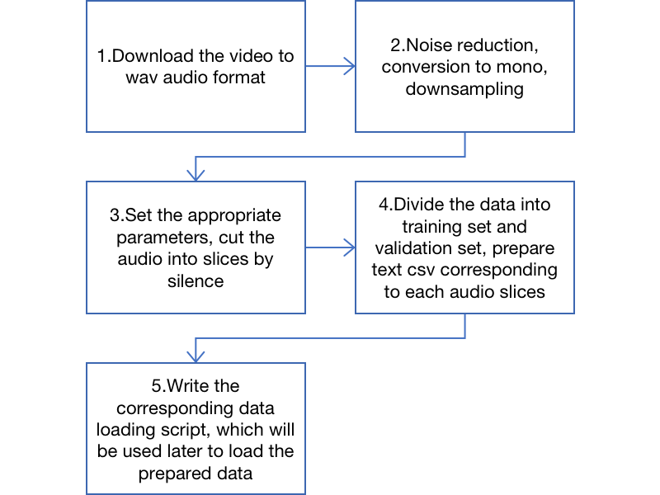

Figure 2.1.5.3(1) Fine-tune Dataset Preparation Workflow

|  |  |
| --- | --- |
| Preparation of Fine-tune Dataset | |
| The audio slices of the training set and validation set and their corresponding correct texts are needed |  |
| Inside the train folder |  |
| train.csv |  |

Table 2.1.5.3(1) Preparation of Fine-tune Dataset

1. **Model Fine-tuning and Settings of Parameters**

During fine-tuning, it is important to note that the ‘Vocab_list’ generated using our own dataset needs to be identical to the ‘Vocab_list’ of the Malaya-Speech STT model we want to fine-tune (see Table 2.1.5.3(3)). We need to add or remove the corresponding elements manually if any difference. Otherwise, the model will not be able to do the subsequent training. Table 2.1.5.3(2) shows some of the key parameters that need to be set for model training：

|  |  |
| --- | --- |
| Setting of Key Fine-tuning Parameters | |
| learning_rate | 0.0001 |
| train_batch_size | 2 |
| eval_batch_size | 8 |
| gradient_accumulation_steps | 2 |
| lr_scheduler_type | linear |
| lr_scheduler_warmup_steps | 1000 |
| num_epochs | 10 |
| mixed_precision_training | Native AMP |

Table 2.1.5.3(2) Fine-tuning Parameters‘ Setting

|  |
| --- |
| Malaya-Speech’s Vocab_list: (total 40 elements) |
| {"": 0, "a": 1, "b": 2, "c": 3, "d": 4, "e": 5, "f": 6, "g": 7, "h": 8, "i": 9, "j": 10, "k": 11, "l": 12, "m": 13, "n": 14, "o": 15, "p": 16, "q": 17, "r": 18, "s": 19, "t": 20, "u": 21, "v": 22, "w": 23, "x": 24, "y": 25, "z": 26, "0": 27, "1": 28, "2": 29, "3": 30, "4": 31, "5": 32, "6": 33, "7": 34, "8": 35, "9": 36, "|": 37, "[UNK]": 38, "[PAD]": 39} |

Table 2.1.5.3(3) Malaya-Speech’s Vocab List

Part of the training process is as below. From the process data we can see that model will get best fine-tune result when training epoch=10.52, after that an overfit will form, so we take the model fine-tuned after 400 steps(epoch=10.52) as our fine-tuned model. Before Step=400, Validation Loss is decreasing, the training is effective, we store the checkpoints of the model at this point, and named the fine-tune model ‘Malaya-Speech_fine-tune_MrBrown’:

After that continued fine tuning can lead to overfitting of the model.

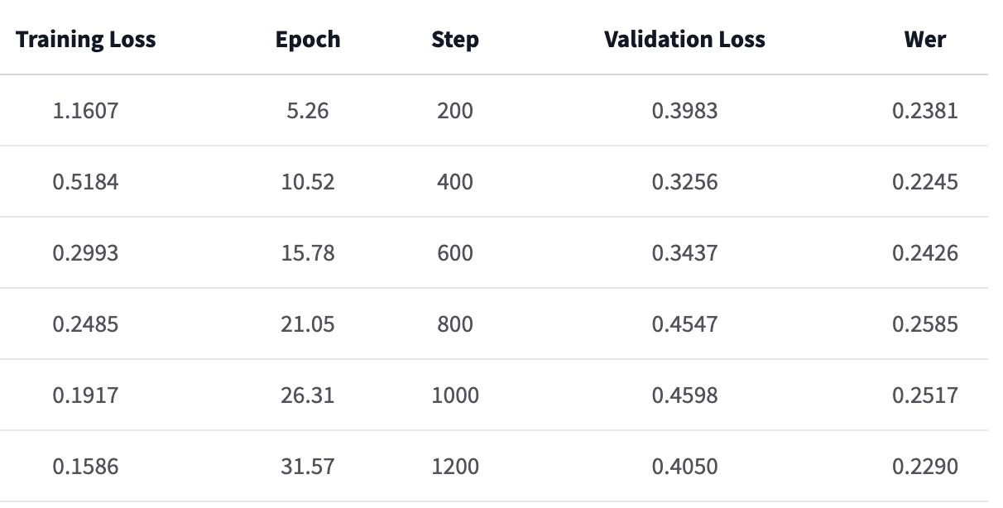

Figure 2.1.5.3(2) Part of the Fine-tuning Training Process

For the test results of the fine-tuned model, please refer to Section 2.2.2 - The Accuracy of Fine-tuned STT Results.

Further improvements can be seen in Section 4.1 for more details.

### 2.1.6 Extra Step - Word Replacement

After getting the text results after STT, we did some other processing on the text - Word Replacement for dealing with proper nouns and Masking Profanity to meet the needs of users at the current stage.

Through the analysis of the STT results, we found that some business proper nouns such as product names that appear infrequently in the training data set will be recognized as some common words with similar pronunciation in the STT. For example, 'UOB' is often recognized as 'you will be'. In this regard, we thought of a way to replace the words.

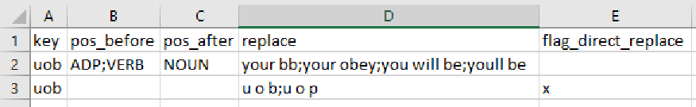

Figure 2.1.6(1) Word Replacement Template

We will summarize the proper nouns that need to be replaced in the template, as shown in Figure 2.1.6(1).

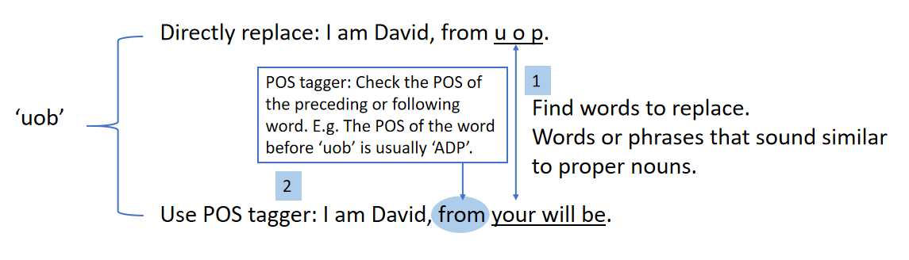

Figure 2.1.6(2) Word Replacement Example

There are two ways to replace: direct replacement and using Pos Tagger to identify the part of speech before and after the word, as shown in the example in Figure 2.1.6(2).

**1. Direct Replacement**

As a rule of thumb, for words like 'u o p', we choose direct replacement. For the words to be replaced directly, we will mark 'x' in the 'flag_direct_replace' of the template. After locking to the position of the word that needs to be replaced in the text, we will directly replace it with the ideal word.

**2. Use POS Tagger**

For some very common words, such as 'you will be', there will be big problems if they are directly replaced by 'uob', so we decide whether to replace them by identifying the part of speech of the word before or after the word or phrase. For example, prepositions rarely appear before 'you will be', while 'uob' often appears with prepositions such as 'from uob' and 'in uob'.

For this type of replacement, after identifying the position of the word or phrase that needs to be replaced, we will obtain the part of speech of the word before or after the word or phrase according to 'universal_tagset', and determine whether it is in the list of parts of speech given by the template. If it is in the list, it will be replaced, otherwise it will not be replaced.

With this word replacement function, although only a dozen words or phrases are replaced in the current template, the overall processed STT result is more accurate in the spelling of proper nouns. When the text is displayed on the web, the displayed text results are more professional and customized due to the correct spelling of proper nouns.

### 2.1.7 Extra Step - Masking Profanity

As the user requested, at present, the user only needs to see the text after the STT displayed on the website, so they want to process the text of the profanity. If they want to perform text analysis such as sentiment analysis in the future, this function may be turned off.

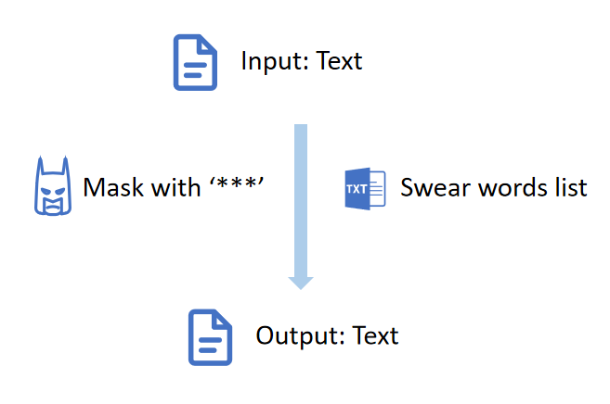

Figure 2.1.7(1) Masking Profanity Workflow

The process is shown in Figure 2.1.7(1). We summarize the words that need to be masked into a swear words list and use regular expressions to replace the words in the list with '***'.

### 2.1.8 Labeling

**1. Purpose**

Labeling is the first module based on text analytics after having STT results. Labeling is to identify which of Speaker 0 and Speaker 1 distinguished by SD module is the Agent and which is the Customer, as shown in Figure 2.1.8(1). Distinguishing Agent and Customer is helpful for subsequent analysis of a series of use cases.

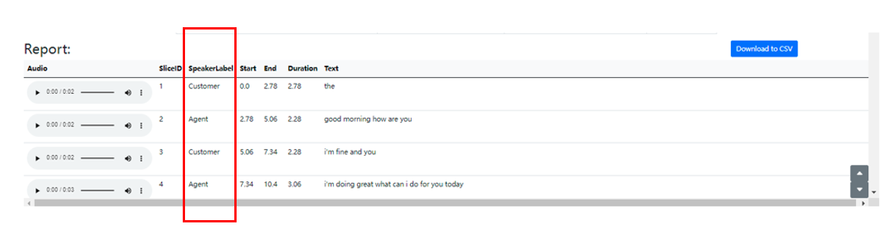

Figure 2.1.8(1) Speaker Labeling Example

**2. Workflow**

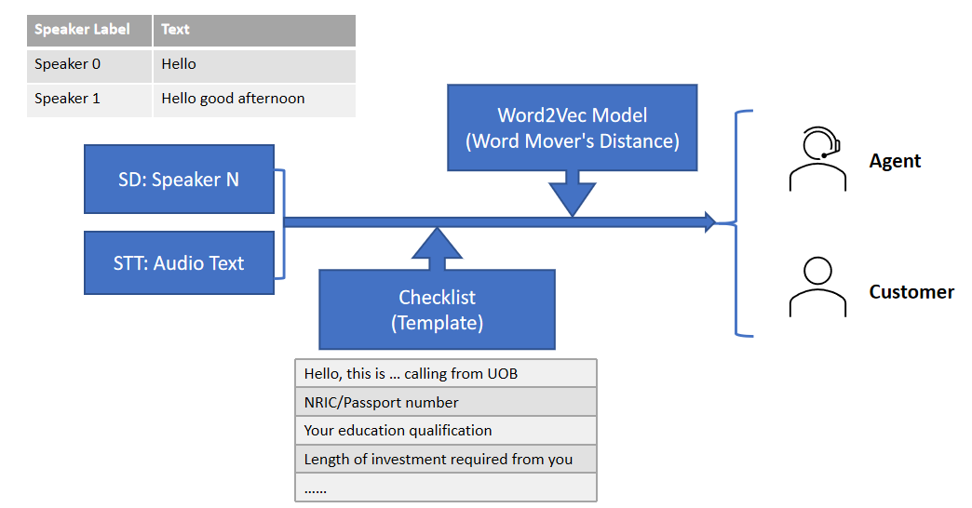

Figure 2.1.8(2) Labeling Workflow

As shown in Figure 2.1.8(2), after we have the discrimination results of Speaker 0 and Speaker 1 of SD and the text results of STT, we use the Agent speech template (In current case called 'checklist') given by the company to calculate the similarity between the speech template and the text of speakers respectively. The more similar speaker is labeled as Agent, and the other is labeled as Customer.

In a more theoretical process, we will convert the text from Speaker 0 and Speaker 1 and the speech template into vectors through the pre-trained Word2Vec model and calculate the similarity through Word Mover's Distance. The smaller the distance, the more similar the text is. If the text is more similar to the Agent speech template, label the speaker as Agent.

**3. Train the Word2Vec Model**

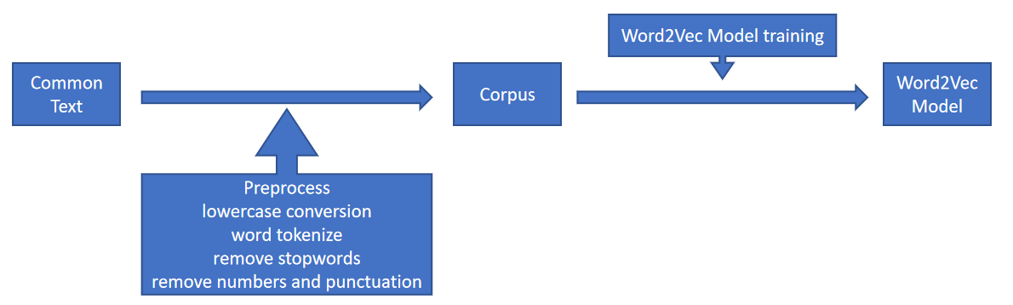

Figure 2.1.8(3) Word2Vec Model Training Workflow

For the Word2Vec model used in the Labeling process, we can use pre-trained models that have been trained by other datasets, or we can train our own Word2Vec model. Here we choose to train a Word2Vec model based on the agent's speech material provided by the company.

The process is shown in Figure 2.1.8(3). First, the text needs to be preprocessed - lowercase conversion, word tokenize, remove stopwords and remove numbers and punctuation, then a corpus is generated. Train the model through the ‘Word2Vec’ function in the ‘gensim.models’ package, and finally generate and output the model.

### 2.1.9 Use Case - Personally Identifiable Information (PII) Detection

After the system was built up, we need to accomplish a use case, which is to detect personally identifiable information in the conversation text. This use case includes two parts. The first one is called ‘Know Your Customer’. Basically, this function needs to detect the NRIC, DOB, and passport number in the conversation. Due to its limited usage, and we do not want to make the system unnecessarily heavy, we deployed a rule-based model to achieve that. The model will identify the information based on keywords.

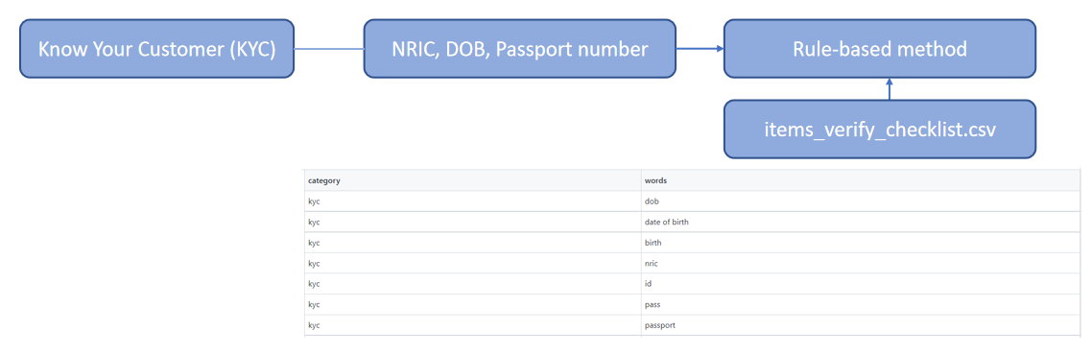

Figure 2.1.9(1) Know Your Customer

Example:

|  |  |  |
| --- | --- | --- |
| Speaker | Content | KYC |
| Agent | Just need to prove your identity, can I have your NRIC number please? | Yes |
| Customer | A1234567B |  |

Another part is more general. The PII function needs to detect all personal information, including email, address, phone number, etc. The PII function is based on regular expression.

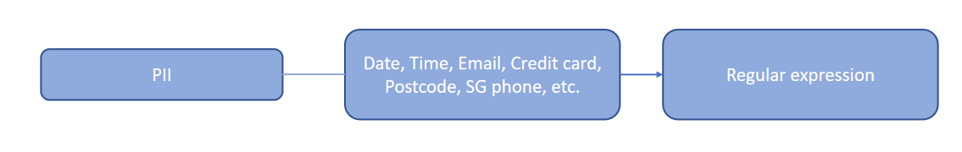

Figure 2.1.9(2) PII

Example:

|  |  |  |
| --- | --- | --- |
| Speaker | Content | PII |
| Agent | Can I have your date of birth and presidential address please? |  |
| Customer | July 25, 1985. Unit 8, 16 Sandilands Road Singapore 546080 | Yes |

## 2.2 Validation of Results

We validated and evaluated the performance of the STT module, word replacement function and labeling model on the company's real business audio recordings.

The following are the evaluation criteria and evaluation results, and the accuracy of the STT module, word replacement function and labeling model will be explained respectively.

### 2.2.1 The Accuracy of STT Results

**1. Evaluation Criteria**

|  |  |  |
| --- | --- | --- |
| Evaluation indicators | Calculation formula | Explanation |
| Accuracy | Accuracy = 1 – WER | The accuracy of the STT results compared to the correct text |
| WER (word error rate) | WER = (Substitutions + Insertions + Deletions) / Number of Words Spoken | Substitution: when a word is replaced (for example, “shipping” is transcribed as “sipping”)  Insertion: when a word is added that wasn’t said (for example, “hostess” is transcribed as “host is”)  Deletion: when a word is omitted from the transcript (for example, “get it done” is transcribed as “get done”) |

Table 2.2.1(1) STT Model Evaluation Criteria

The evaluation criteria for the STT model are shown in Table 2.2.1(1).

Next, the results of two different counting methods, By character and By words, will be given for STT accuracy (Table 2.2.1(4)). The difference between By character and By words can be illustrated with an example:

Example:

|  |  |
| --- | --- |
| Accurate transcript | STT results |
| justin | just in |

By character the accuracy for the example is 83.33%. Differences of only one space will be considered.

By words the accuracy for the example is 0%. Because there are no words to match.

**2. Test Set Size**

Test Set Size for Table 2.2.1(2), 2.2.1(3): 3 real recording audios (CC001, CC003 and CC038(TOP 60 slices))

Test Set Size for Table 2.2.1(4): 17 real recording audios (See the Test documentation for details.)

**3. Test Results**

|  |  |
| --- | --- |
| Toolkit | Average accuracy (By character) |
| VOSK | 64.28% |
| Malaya-Speech | 73.10% |

Table 2.2.1(2) STT Pre-trained Model Test Results

For our final chosen STT pretrained model, VOSK and Malaya-Speech performed relatively well. Comparing the two, VOSK's recognition of standard English is relatively good. While in real company audio, the problem of sound quality and accent makes it less accurate than Malaya-Speech's pre-trained model based on Singlish training. Table 2.2.1(2) shows the accuracy tested on real company audios. The average accuracy of Malaya-Speech is about 10% higher than that of VOSK.

For the real recordings given by the company, the pre-trained STT model encountered the following three problems:

* Sound quality is not good, but STT Model is sensitive to sound quality.
* Actual audios have heavy Singaporean accent.
* Some proper nouns rarely appear in the training set, making the recognition inaccurate.

In order to improve the accuracy of STT, we proposed three targeted solutions for these three problems:

* Before STT process, we add audio pre-processing (Noise Reduce, Speech Enhancement and Audio Reformat) functions to improve the sound quality.
* During STT process, we try to fine-tune the pretrained model based on the company audios to better accommodate the Singaporean accent in the company's audio.
* After STT process we add word replacement function to replace some misheard proper nouns.

The test results after improvement are shown in Table 2.2.1(3).

|  |  |
| --- | --- |
| Improvement solutions | Average accuracy  (By character) |
| Pretrained Malaya-Speech Model | 73.10% |
| Add audio pre-processing functions | 74.14% |
| Add audio pre-processing functions and word replacement function | 74.29% |

Table 2.2.1(3) STT with Improvement Solution Test Results

After audio pre-processing and word replacement, although the magnitude is not very large, the accuracy has also improved to a certain extent.

Next, we transcribed more audios to test the accuracy of the STT model.

|  |  |  |
| --- | --- | --- |
| Model | Accuracy  (By character) | Accuracy  (By words) |
| Malaya-Speech large-conformer-singlish | 72.42% | 66.66% |

Table 2.2.1(4) STT Accuracy

Currently, the average accuracy of STT in 17 company audios in test is 72.42%, as shown in Table 2.2.1(4). The accuracy of this result is not very high in the current STT field, but it is acceptable for audio with poor sound quality and a heavy Singaporean accent.

You can refer to Tabel 2.2.1(5), the test results of the Malaya-Speech team on the Singlish corpus for comparison:

|  |  |  |
| --- | --- | --- |
| Toolkit | Accuracy  (By character) | Accuracy  (By words) |
| Malaya-Speech large-conformer-singlish | 96.41% | 92.99% |
| Google Speech API | 69.74% | 50.59% |

Table 2.2.1(5) Accuracy tested on Singlish corpus by Malaya-Speech team

### 2.2.2 The Accuracy of Fine-tuned STT Results

**1. Evaluation Criteria**

Same with previous STT Evaluation：

|  |  |  |
| --- | --- | --- |
| Evaluation indicators | Calculation formula | Explanation |
| Accuracy | Accuracy = 1 – WER | The accuracy of the STT results compared to the correct text |
| WER (word error rate) | WER = (Substitutions + Insertions + Deletions) / Number of Words Spoken | Substitution: when a word is replaced (for example, “shipping” is transcribed as “sipping”)  Insertion: when a word is added that wasn’t said (for example, “hostess” is transcribed as “host is”)  Deletion: when a word is omitted from the transcript (for example, “get it done” is transcribed as “get done”) |

Table 2.2.2(1) STT Model Evaluation Criteria

**2. Test Set Size**

We only have model results fine-tuned on the "MrBrown" dataset so far, for reference: We simply used another audio of MrBrown, ‘Kim Huat in... The Moon Who Loved Me’ (duration: ) to test the STT comparison results.

**3. Test Results**

the STT comparison results are as follows：

|  |  |
| --- | --- |
| model | Accuracy on ‘Kim Huat in… The Moon Who Loved Me’ |
| Malaya-Speech | 0.80438999 |
| Malaya-Speech_fine-tune_MrBrown | 0.825860271 |
| Google API | 0.715328467 |

Table 2.2.2(2) Comparison of Test Accuracy of Fine-tuned Models

|  |  |  |
| --- | --- | --- |
| Model | Correct transcript | STT result |
| Malaya-Speech | hello this is **kim huat singapore number one** work from home fan … | hello this is **kim what singapore nubo one** work from homefan… |
| Malaya-Speech_fine-tune_MrBrown | hello this is **kim huat singapore number one** work from home fan … | hello this is **kim huat singapore number one** work from home fan … |
| Google API | hello this is **kim huat singapore number one** work from home fan … | Hello. This is **keep watching upon number one** work from home fan… |

Table 2.2.2(3) Comparison of Test Result of Fine-tuned Models

As shown above, we got a more obvious fine-tune effect on a very small dataset. In particular, the original model cannot recognize ‘kim huat singapore number one’, but correctly recognizes the phrase after fine-tuning. This is because there are two ‘Singapore number one’ audio and the corresponding correct text in the training set, although they are from the audio of the other two videos. So fine-tune Malaya-Speech is feasible and effective. When the company is equipped with a GPU capable of training, the company audio can be prepared accordingly to fine-tune the STT model.

### 2.2.3 The Accuracy of Word Replacement Function

**1. Evaluation Criteria**

|  |  |  |
| --- | --- | --- |
| Evaluation indicators | Calculation formula | Explanation |
| Confusion Matrix |  | A 2*2 matrix that records the number of slices that need to be replaced, that do not need to be replaced, that have been replaced, and that have not been replaced. |
| Accuracy | Accuracy = (TN+TP)/(TN+TP+FN+FP) | The overall accuracy of the word replacement function. |
| Recall | Recall = TP/(TP+FN) | How many slices that need to be replaced are replaced. |
| Precision | Precision = TP/(TP+FP) | How many of the replaced slices are replaced correctly. |

Table 2.2.3(1) Word Replacement Function Evaluation Criteria

The evaluation criteria for the word replacement function are shown in Table 2.2.3(1).

**2. Test Set Size**

Test Set Size: 30 real recording audios (2521 slices) (See the Test documentation for details.)

**3. Test Results**

|  |  |  |
| --- | --- | --- |
|  | Not replaced | Replaced |
| No need to replace | 2427 (TN) | 3 (FP) |
| Need to replace | 26(FN) | 65 (TP) |

Table 2.2.3(2) Word Replacement Function Confusion Matrix

The confusion matrix is shown in Table 2.2.3(2).

|  |  |
| --- | --- |
| Evaluation indicators | Values |
| Accuracy | 98.85% |
| Recall | 71.43% |
| Precision | 95.59% |

Table 2.2.3(3) Word Replacement Function Test Results

According to Table 2.2.3(3), in the company audio test, the overall accuracy is 98.85%. The recall is 71.43%, that is, about 71.43% of the proper nouns that need to be recognized can be replaced. And the precision is 95.59%, that is, about 95.59% of the replacements are correct. Although the Recall is not very high, it guarantees a high Precision, which is in line with expectations.

### 2.2.4 The Accuracy of Labeling Model

**1. Evaluation Criteria**

|  |  |  |
| --- | --- | --- |
| Evaluation indicators | Calculation formula | Explanation |
| Accuracy | Accuracy = Correct /Total | How many of the audios’ Agent and Customer labels are correct. |

Table 2.2.4(1) Labeling Model Evaluation Criterion

The evaluation criterion for the labeling is shown in Table 2.2.4(1).

**2. Test Set Size**

Test Set Size: 30 real recording audios (See the Test documentation for details.)

**3. Test Results**

|  |  |
| --- | --- |
| Evaluation indicators | Values |
| Accuracy | 96.67% |

Table 2.2.4(2) Labeling Model Test Result

The labeling model is used to identify whether the speaker is an agent or a customer. We tested it with 30 recordings of real business conversations from companies to see if the labels were correct. The result is shown in Table 2.2.4(2). The accuracy is 96.67%, which is a good one.

# 3. Deliverables

## 3.1 Storage

**1. Components**

Figure 3.1(1) shows the storage components in final system.

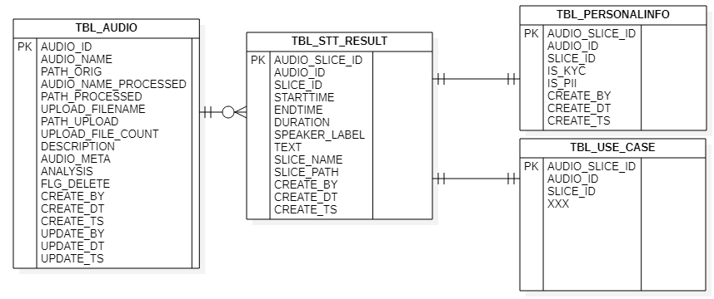

Figure 3.1(1) Storage Components

We have MySQL database to store processing data. Main tables store the master data – audio information and transaction data – STT results and analysis results. Due to the consideration of data protection, analysis results in different use cases are designed to be saved in different tables. The structure is extensible with new tables. Besides the main tables, we also designed some assistance tables, in order to make user actions traceable and make system work in a structured way.

Additionally, we use File System to store media files, including the uploaded files and processed audio files.

With both components work together, our system can successfully store both media files and processing data.

**2. Scripts**

We provided some scripts to help the company to initialize the storage settings in their final server, including creating the necessary databases, tables and stored procedures, initializing configuration data in tables and also checking whether the necessary objects are successfully created.

And for their daily operations, we also provided support scripts for system to run in the designed ways. The scripts are recommended to be set as scheduled jobs to run regularly.

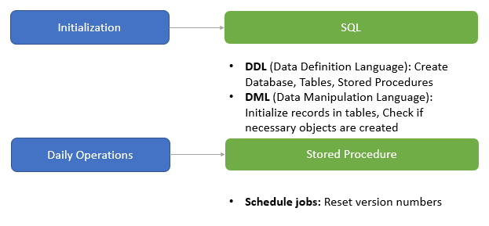

Figure 3.1(2) Storage Scripts

## 3.2 Web Portal

A web portal is created for end users to manage the audios they would like to analyze. It is built with Django Framework using Python. The models we have verified are integrated with designed front-end UI to work as an end-to-end system. Figure 3.2(1) shows current website structure and main functions in each page.

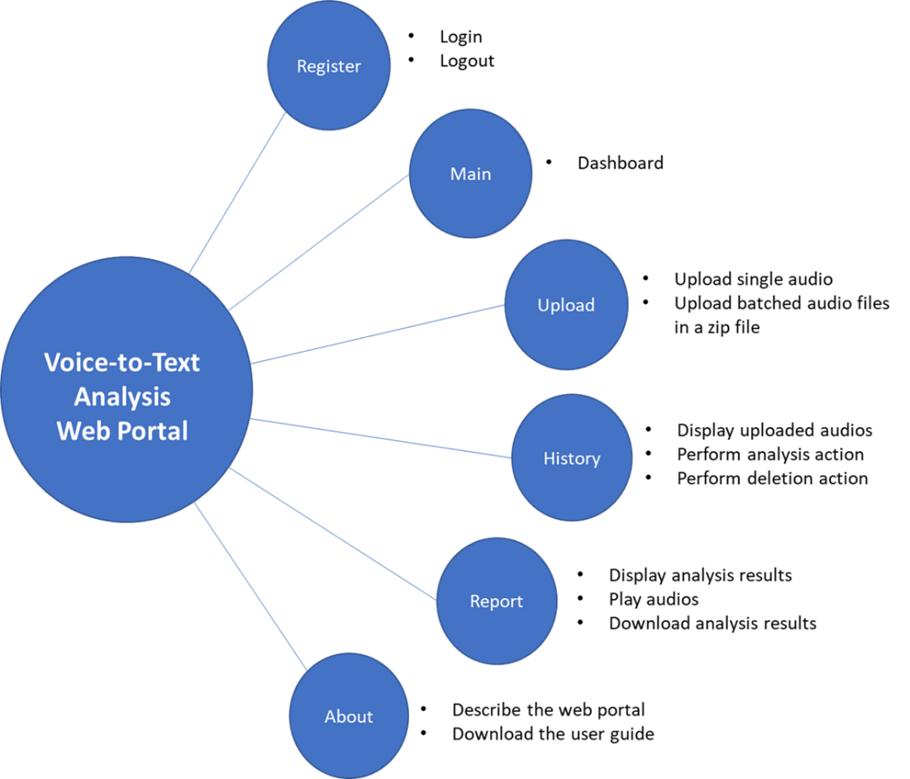

Figure 3.2(1) Website Structure & Functions

Below are details of the web portal.

1. **Register Page**

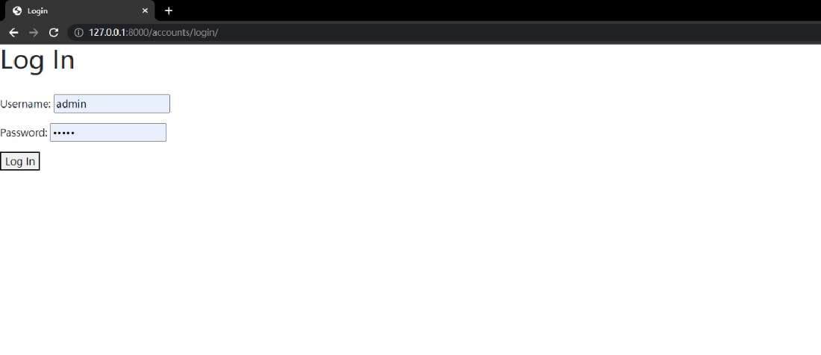

Figure 3.2(2) Register Page

User can log in from this page with his/her username and password.

1. **Main Page**

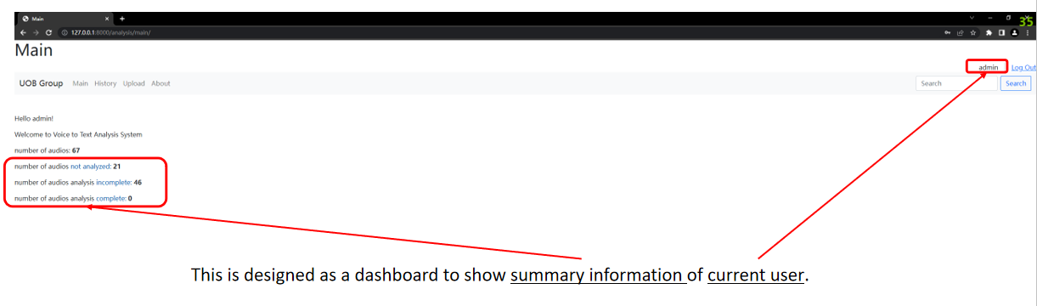

Figure 3.2(3) Main Page

After login, user will see this main page, which is designed as a dashboard to show the summary information of current user, including the number of audios have been processed, the number of audios in history and so on.

1. **Upload Page**

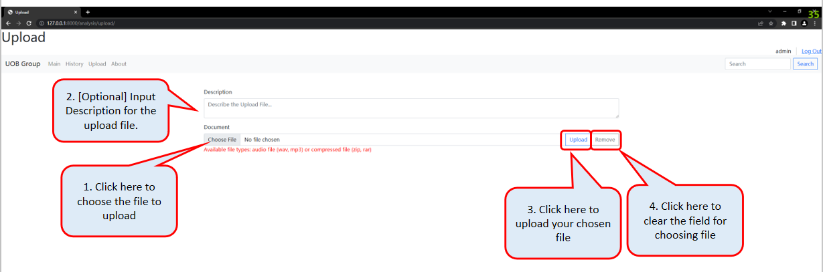

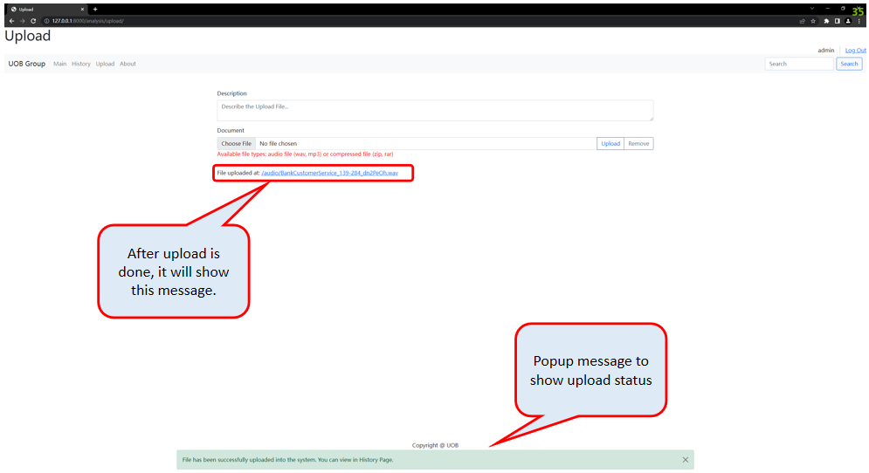

Figure 3.2(4) Upload Page

From this page, user is allowed to upload one single audio file or a batch of files compressed in a zip or rar file to the system. The available file format is highlighted in the note. What’s more, user can give a description of the uploaded file which is optional. Then, user can click the ‘Upload’ button to upload the selected file or cancel the item to be uploaded.

After uploading is done, the window will show a message at the bottom of the page, saying the file has been successfully uploaded to the system.

Next step, user can go to the history page by clicking on the ‘History’ tab in navigation bar.

1. **History Page**

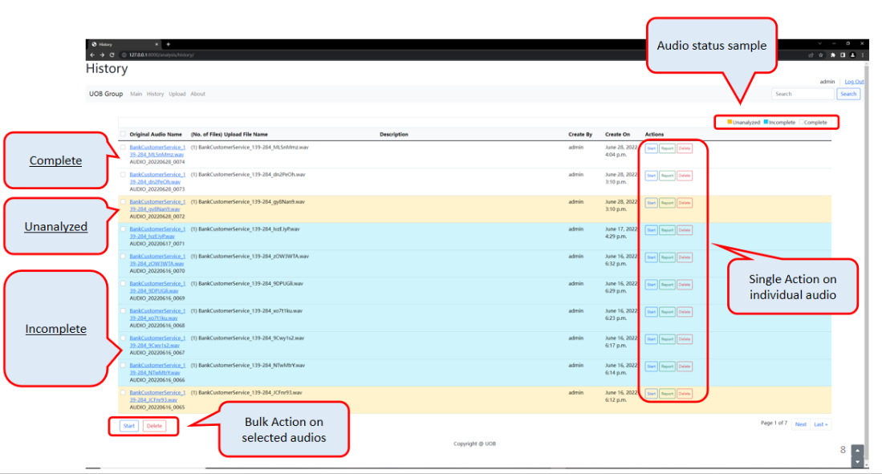

Figure 3.2(5) History Page (1/7)

The history page shows all uploaded audios by current user in history.

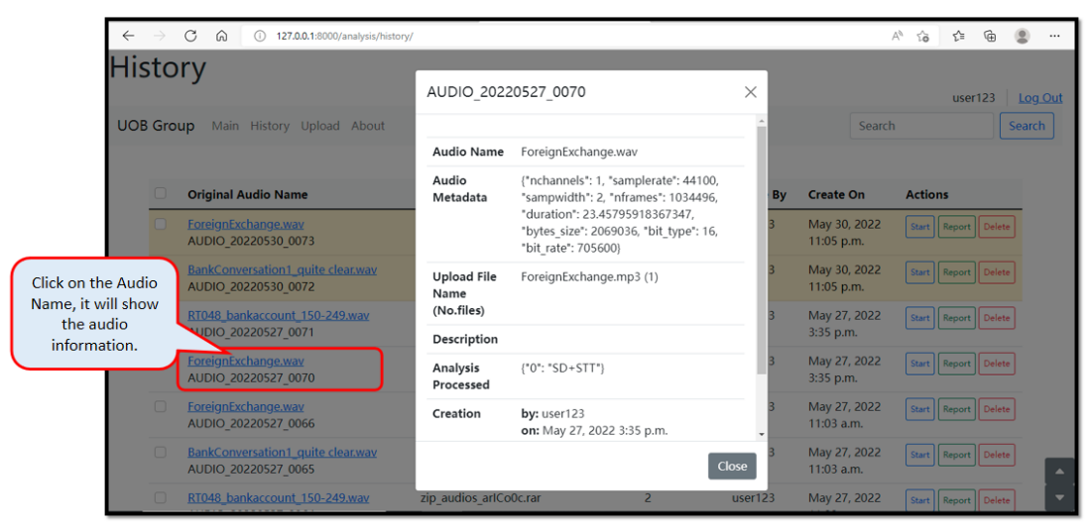

Figure 3.2(6) History Page (2/7) - Audio Information

By clicking on the audio name, user can see the master data of the audio, including the audio ID, the audio name, metadata, uploaded file name, description during upload, analysis that have been performed, creation information and update information.

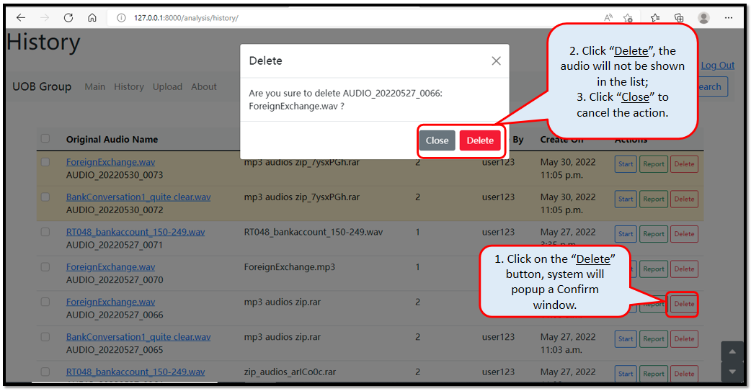

Figure 3.2(7) History Page (3/7) - Delete Action

User can click the ‘Delete’ button in the action column of each audio to remove the audio that is no longer needed. After the deletion, user will not see it on history page anymore.

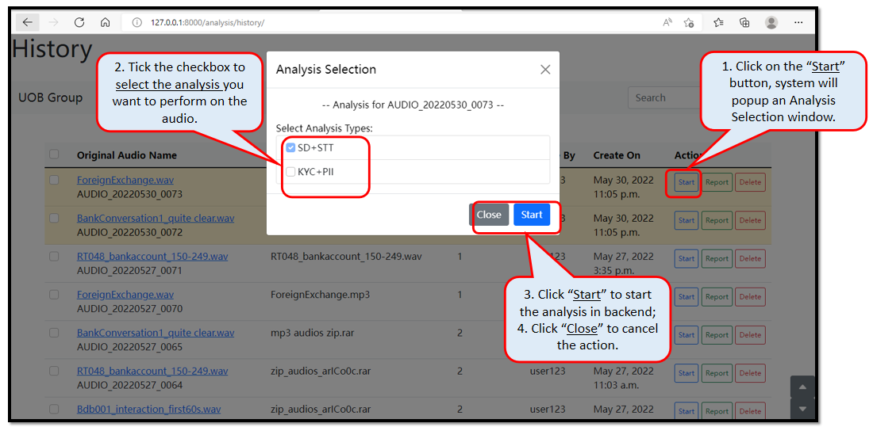

Figure 3.2(8) History Page (4/7) - Start Action

User can click the ‘Start’ button in the action column of each audio to perform the analysis on individual audio. User needs to choose the analysis types before submitting the request to the backend.

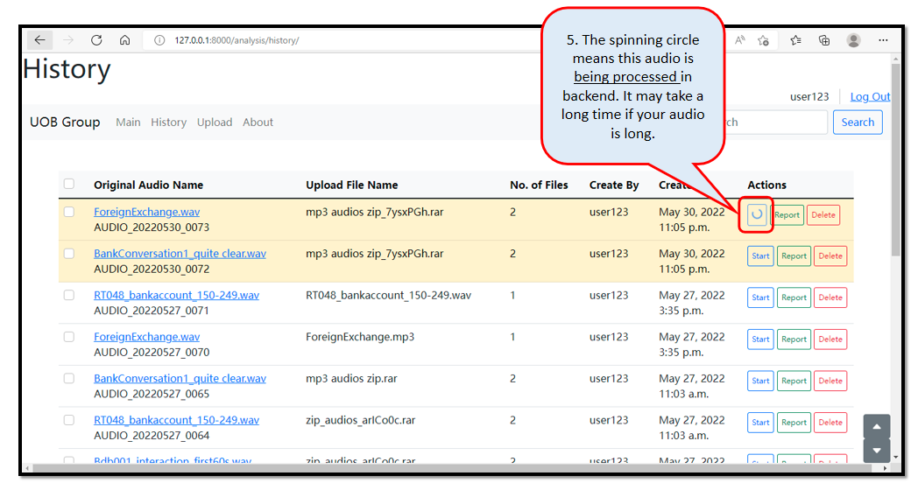

Figure 3.2(9) History Page (5/7) - Analysis Running

The history page shows a spinning circle in the action column of the audio that in analysis process.

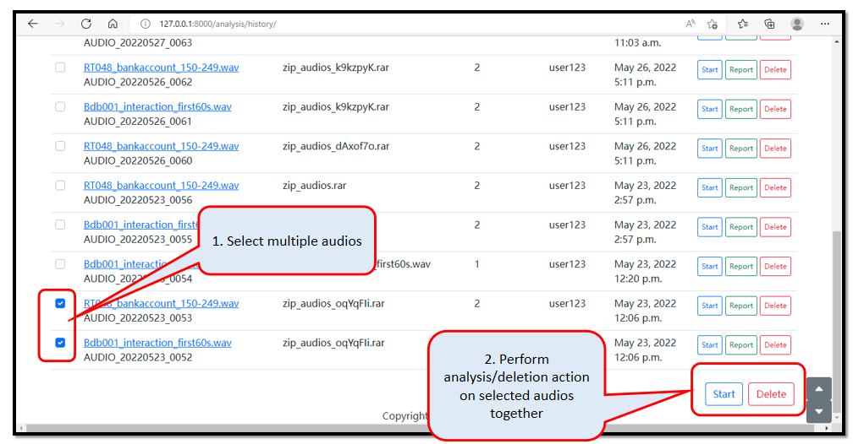

Figure 3.2(10) History Page (6/7) - Batch Process

If the user has a number of audios to be performed same action together, the system allows the user to select multiple audios by ticking the checkbox in front of each line, then go to the bottom of the page and click on the batch-processing ‘Start’ button or ‘Delete’ button.

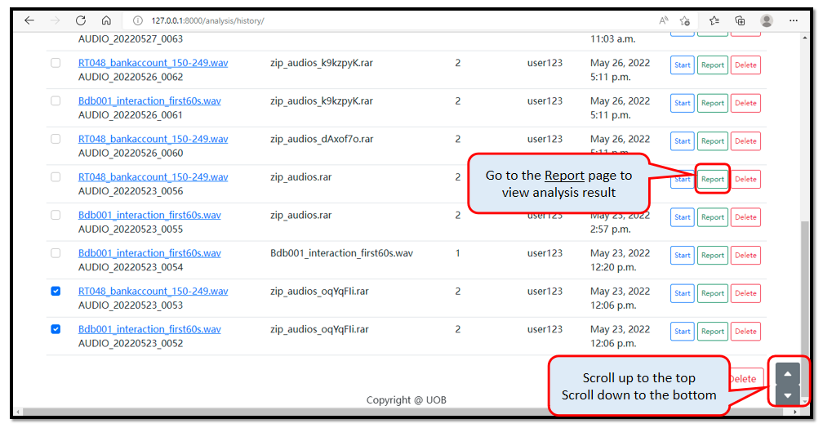

Figure 3.2(11) History Page (7/7) - Report Button

After the analysis is done, user can click on the ‘Report’ button in the action column of each individual audio then view the analysis results of corresponding audio.

1. **Report Page**

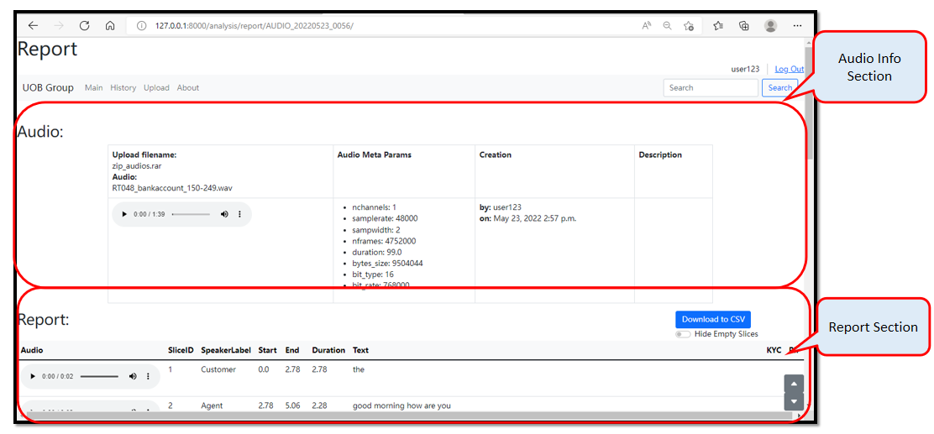

Figure 3.2(12) Report Page (1/3)

If user wants to see the analysis results, he/she can click on ‘Report’ button in the history page.

Audio information is shown at the top of the page, followed by its analysis results.

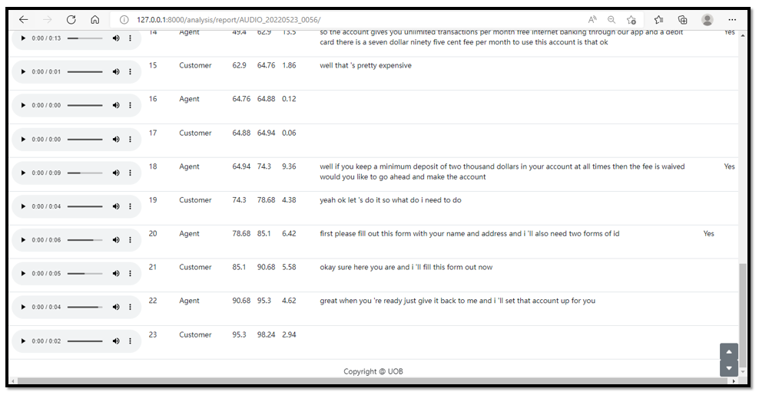

Figure 3.2(13) Report Page (2/3) - Analysis Results

Users can listen to the whole audio or slices on this page. A csv version of the report can also be downloaded.

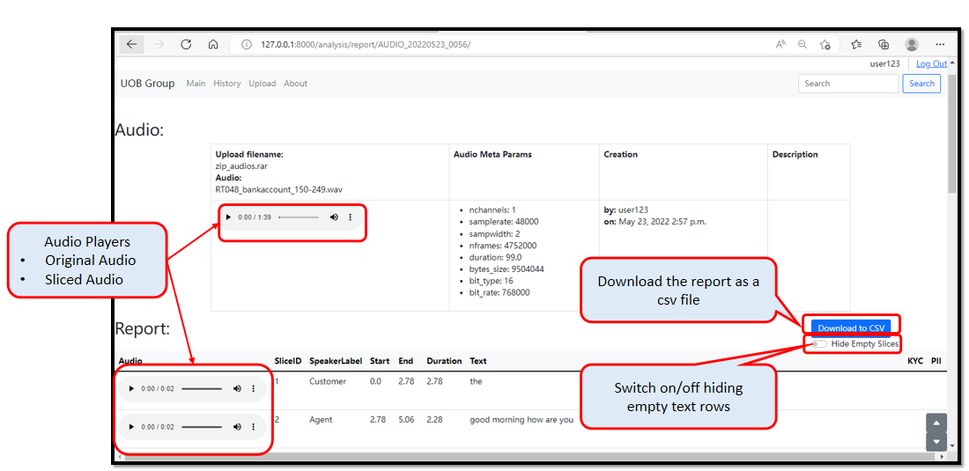

Figure 3.2(14) Report Page (3/3) - Functions

1. **About Page**

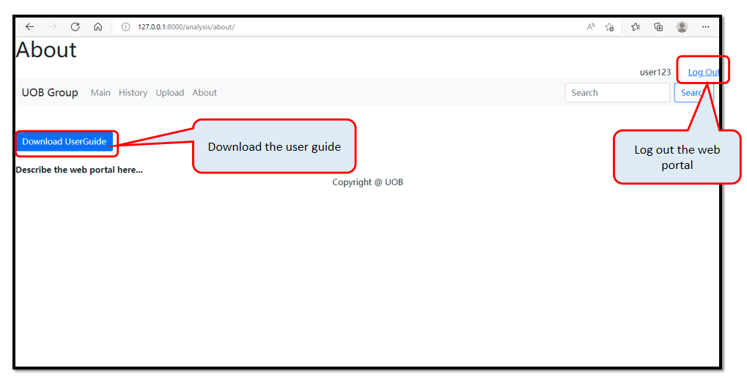

Figure 3.2(15) About Page

This ‘About’ page is designed to describe the system and allows user to download the user guide to their local personal computer. It is easier for auditors to learn about how to use the system.

## 3.3 Codes, Models & Configuration Files

The deliverables also include codes, models and configuration files as listed below.

1. **Codes**

* Front-end & Back-end codes of the system (Django Project)
* Fine-tune Malaya-Speech STT Model
* Fine-tune Speaker Labeling Model

1. **Models**

Below are the models we are using in current system.

* resnet-unet model for Noise Reduction (Malaya-Speech Repo)
* Unet model for Speech Enhancement (Malaya-Speech Repo)
* A deep learning model (voice encoder) for Speaker Diarization (Resemblyzer Repo)
* Wav2Vec2 model for Speech-To-Text (Malaya-Speech Repo)
* large-conformer-singlish model for Speech-To-Text (Malaya-Speech Repo)
* Word2Vec model for Labeling (gensim Repo)

1. **Configuration Files**

Below are configuration files for system administrator to maintain to setup and improve the system.

* STT_word_replacement_template.csv: to be used in Word Replacement function. Admin can maintain it to improve the system further.
* swear_words_list.txt: to be used in Profanity Masking function. Admin can maintain the swear words to mask in this list.
* labeling_checklist.txt: to be used in Speaker Labeling function. This is the template for agents to use during their communication with their customers. Admin needs to maintain this list if the template changes.
* items_verify_checklist.csv: to be used in KYC detector function. Admin can add what KYC requires in the list.

## 3.4 Documentations

We created and maintained user guides and documentations as listed below.

1. **Project Design Document**

User Requirements, Proposed Solution, Architecture, Technical Design, Deliverables

1. **Test Documentation**

Guide for testing, Code for testing, Functions testing results, Original test files

1. **Voice-to-Text Analysis Web Portal User Guide**

（Embedded in codes, path: “. /analysis/utils/” ）

A user guide (format: PowerPoint); A demonstration video

1. **Model Maintenance Guide**

Model Fine-tuning/Training Process (STT model & Labeling model)

1. **Guide to Setup Web**

System Setup Requirements, Process Flow, Parameters to Setup, MySQL Setup

1. **Codes Maintenance Document**

Project (Codes) Structure, Version Control, Template/Checklist Files Maintenance

1. **Web UI Design**

UI design prototype

# 4. Recommendations for Further Work

## 4.1 For Finetune STT Model

**1. Build a 5-gram language decoder for the wav2vec2 model**

The 5-gram language decoder model is added after the wav2vec2 model to correct some strange output words (non-existent words) of wav2vec2, while making the sentence expression more logical. wav2vec2 is a very sensitive speech model, so it has a very good detection and learning effect on phonemes, but the decoding part is not based on the vocabulary, but based on the alphabet (the model is based on the alphabet), so if The sound quality is not good, it is prone to generate combinations that are not words (spelling errors). We need to add a correction model 5-gram after it. This model can identify the relationship between words based on probability, and give the correct word that is similar to the pronunciation and phoneme and has a higher probability of appearing.

Training a 5-gram model requires a larger amount of text plus part of the audio text of the UOB. (The vocabulary of the language model is built based on the input text. If there is no UOB text and there is no "UOB" in the training text, the word "UOB" will never appear when the model decodes, and the model will think that the word Misspell).

This method of combining the Wav2vec2 model with the 5-gram language decoder model was launched in 2022, and has been continuously improved and revised, so we suggest you can continue to pay attention to it.

The training tutorials given so far: https://huggingface.co/blog/wav2vec2-with-ngram

The above tutorials have small bugs during testing, and others have pointed out on the Internet. The author has not officially corrected them yet. It is recommended to refer to this code that I have corrected:

**2.Fine-tune Malaya-wav2vec2**

Since wav2vec2 is indeed a model that captures phonemes very well and can be fine-tuned, for some words that are commonly used in UOB but not commonly used in daily contexts (such as some product names), you can continue to create a training set according to fine-tune guidance and do the Fine-tune on it.

Fine-tune tutorial and code:

Tutorial：

* Fine-tune STT model Guidance

The required code (also written in guidance):

* UOB_fine_tune_dataset_making.ipynb
* uob_dataloading.py
* wer.py
* UOB_Malaya-speech_fine-tune.ipynb

**3. Replace Malaya-wav2vec2 pretrained model**

Since so far (2022.6.30), the pre-trained model based on the wav2vec2 framework given by malaya-speech has only one model called "malay-huggingface/wav2vec2-xls-r-300m-mixed" (https:// huggingface.co/malay-huggingface/wav2vec2-xls-r-300m-mixed), is also the model we are using and fine-tuning now. It is based on "Malay, Singlish, Mandarin" three languages mixed training. If the author of malaya-speech launches a pre-trained model based on the wav2vec2 framework and trained entirely on the singlish corpus, this model can be used to replace the old model.（The main page where malaya-speech launches wav2vec2 based models is at:：https://huggingface.co/malay-huggingface，can continue to follow.）

As long as the framework of the model is based on wav2vec2, it can be completely fine-tuned based on the " Fine-tune STT model Guidance " given by us. The only difference may be that minor adjustments need to be made when generating vocab_list, adding or deleting vocab_list. elements to make the vocab_list fully match the new pre-trained model.

**4. For finetune/training data preparation**

It is recommended that when preparing fine-tuned training data, you can use the method of writing scripts and recordings to simulate real scenes. Such audio and text will be more accurate, making fine-tuning more accurate. The way of dictation currently used does not guarantee the complete correctness of the text.

## For Web UI Design

* (report page) add authentication validation for directly accessing report page via URL
* (upload page) add a progress bar for upload file
* (history page) suggest to disable start&delete for admin account
* (base_analysis.html) add Search Function, otherwise comment the codes in html.
* (history page) create a new column "message" in database table "analysis_audio" to save latest error message of corresponding audio. Show this info in audio master data (show in the modal that popup after click the audio name on history page). Therefore, user will know why the audio cannot finish analysis.
* (views.py) save messages into column "message" in "analysis_process_log" table
* (views.py/history) reconsider the design of processing analysis action, in case lots of users request to perform analysis during same period and lots of models running together might cause out of memory issue.

## 4.3 For Text Analysis (Further Use Cases)

**1. For KYC & PII**

* The detection is only based on Regex, so it is not so ‘brilliant’, later can change it to model-based, but need to prepare enough data for training or finetune.
* Currently the function can only detect KYC & PII info, in the future this information can be used for user verification and agent performance tracking.

New Product Detection:

* If any new product need to be detected in the future, you can follow the KYC function to create one, I have included a sample in the ‘items_verify_checklist.csv’, and it is also the same for other items.

**2. For masking profanity**

It is recommended to turn off this function when sentiment analysis on text is required in the future.